





SprINT 2 IMpLEMENTaTION



PrOJEcT TIMELINE: 12.10.2022 TO 18.10.2022

INDEX

## Introduction

* 1. Purpose 3
  2. Intended audience 3
  3. Intended use 3
  4. Scope 3

## Overall description 3

* 1. Assumptions and dependency 3

## System feature and requirements

* 1. Socket Programming 4
  2. Functions
     1. translate**()**
     2. writetofile**()**
     3. modify()
     4. delete()
  3. System requirement

-------------------------------------------------- 5

----------------------------------------------- 5

-------------------------------------------------- 5

-------------------------------------------------- 5

-------------------------------------------------- 5

-------------------------------------------------- 6

* + 1. Tools to be used 6
  1. System feature 6

4. **Data Flow Diagram**

4.1 DFD level 0 7

4.2 DFD level 1 8

5. **Flow Chart**

5.1 chart for client side 9

5.2 chart for server side 9

# 1.



INTrODUcTION: -

The introduction of the software requirement specification provides an overview of the entire software. The entire SRS with overview description purpose, scope, tools used and basic description. The aim of this document is to gather, analyze and give an in-depth insight into the language translator application by defining the problem

statement in detail. The detailed requirements of the language translator application are provided in this document.

* 1. **Purpose**: **-** The purpose of this document is to show the requirements for the language translator application, in which clients/users can get the desired translation of the word they provide.
  2. **Intended Audience: -** This document is intended to be read by the client.
  3. **Intended Use: -**
     + Development Team
     + Maintenance Team
     + Clients

Since this is a general-purpose software any one can access it from the client side.

* 1. **Scope: -** This project aims to create the development of a language translator application which takes the client’s information such as word to be translated, source language and matches it along with the files in the database created in the server side and returns the translated word meaning that the client wishes to know.



2. OvEraLL DEscrIpTION: -

It is a language translator application in which the server has admin access where it can perform various functions like adding new language, adding meaning, modifying and deleting words in the database. The application then correlates this data and returns the respective translated words to the clients based on the input target and source language.

If the words are not present in the database then it gives the error message to the user that “words not found”.

Moreover, the application has the capability to generate files which have the information of various word meanings in different languages.

* 1. **Assumptions and Dependency: -**
     + System should have Ubuntu Linux/cygwin installed.
     + System should have either 4GB or more RAM.
     + The service is used preferably on a desktop or laptop.

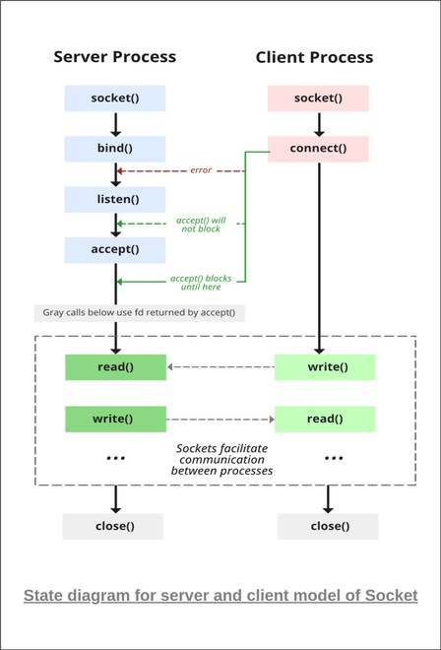

3. SysTEM FEaTUrEs aND REQUIrEMENTs: -

**Socket Programming:-**



3.1

Socket programming is a way of connecting two nodes on a network to communicate with each other. One socket(node) listens on a particular port at an IP, while the other socket reaches out to the other to form a connection. The server forms the listener socket while the client reaches out to the server.

**Stages of Server**

* **Socket Creation**
* **setsockopt:-**This helps in manipulating options for the socket referred by the file descriptor sockfd. This is completely optional, but it helps in reuse of address and port.
* **Bind**:- After the creation of the socket, the bind function binds the socket to the address and port number specified in addr(custom data structure).
* **Listen**:-It puts the server socket in a passive mode, where it waits for the client to approach the server to make a connection.
* **Accept**:-It extracts the first connection request on the queue of pending connections for the listening socket, sockfd, creates a new connected socket, and returns a new file descriptor referring to that socket.

## Stages of client

* **Socket connection**:- Exactly same as that of server’s socket creation
* **Connect**:-The connect() system call connects the socket referred to by the file descriptor sockfd to the address specified by addr. Server’s address and port is specified in addr.
  1. **Functions: -**
     1. **translate():** When client gives the input word, the target and source language, this function matches the word from the text file, if the word is available in the text file , it returns the word meaning.
     2. **writeToFile():** This function is used to create new language and alos add new meanings in the text file.
     3. **modify():** This function is used to replace the meaning of the words that were incorrectly written previously.
     4. **delete():** This function deletes the word meaning that is no longer required. It basically deletes the entire line containing that word and in the output screen displays the remaining contents of the text file.



3.3 SysTEM REQUIrEMENTs: -

## Tools to be used:

* + - * **System Programming**:- Systems programming covers data and program management, including operating systems, control programs, network software, and database management systems.
      * **Linux**:- Linux is used in the following ways: Server OS for web servers, database servers, file servers, email servers and any other type of shared server.
      * **C Programming**:- C programming language is a machine-independent programming language that is mainly used to create many types of applications and operating systems such as Windows, and other complicated programs such as the Oracle database, Git, [Python](https://www.simplilearn.com/learn-the-basics-of-python-article) interpreter, and games and is considered a programming foundation in the process of learning any other programming language.
      * **C File Handling**:- File handling in C enables us to create, update, read, and delete the files stored on the local file system through our C program. The following operations can be performed on a file.
      * **Gcov**:-It is a test coverage program. It creates a logfile called *sourcefile.gcov* which indicates how many times each line of a source file *sourcefile.c* has executed
      * **Gprof**:-Gprof is a performance analysis tool used to profile applications to determine where time is spent during program execution.
      * **Splin**t:-Splint is a programming tool for statically checking C programs for security vulnerabilities and coding mistakes.
      * **make:-** The make utility requires a file, Makefile (or makefile), which defines set of tasks to be executed. You may have used make to compile a program from source code.

# SysTEM FEaTUrEs: -

* + - Supportability: The system is easy to use.
    - Design Constraints: The system is built using only C language.
    - Usability: The language translator application is used to translate words into multiple languages that the client wishes to know. The application is also able to generate the appropriate meaning of the word.
    - Reliability and availability**:** The system is available 24/7 that is whenever the user would like to use the system, they can use it up to its functionalities.
    - Performance: The system will work on the user’s terminal as well as on the server side terminal